**1203 Database 1 - Take Home Assignment**

**Group 47**

**Scenario 1 – Sewana Property for Rent**

**Group Members**

|  |  |  |
| --- | --- | --- |
| **Registration Number** | **Index Number** | **Name** |
| 2020/CS/185 | 20001851 | THILAKARATHNA K.D.D.O. |
| 2020/CS/187 | 20001878 | THILINIKA K.A.H. |
| 2020/CS/189 | 20001894 | UMAYANGA N.G.J. |
| 2020/CS/191 | 20001916 | UYANAHEWA D.D. |



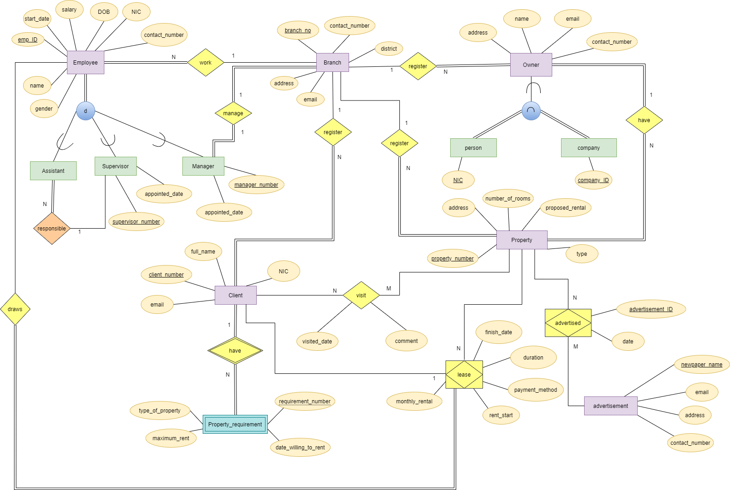**EER Diagram:**

**Mapping:**

Employee [emp_ID, gender, name, start_date, salary, DOB, NIC, contact_number, **Branch_no(fk) ]**

Assistant [emp_ID, **supervisor_number(fk)** ]

Supervisor [emp_ID, supervisor_number, appointed_date]

Manager [emp_ID, manager_number, appointed_date, **Branch_no(fk) ]**

Branch [Branch_no, contact_number, address, email, district]

Owner [owner_ID, address, name, email, contact_number, **Branch_no(fk) ]**

Person [NIC, **owner_ID(fk) ]**

Company [company_ID, **owner_ID(fk) ]**

Property [property_number, address, number_of_rooms, proposed_rental, type, **owner_ID(fk),** **client_number(fk), Branch_no(fk) ]**

Advertisement [newspaper_name, email, address, contact_number]

Advertised [advertisement_ID, date, **newpaper_name(fk), property_number(fk) ]**

Client [clinet_number, email, full_name, NIC, **Branch_no(fk) ]**

Visit [**property_number(fk), client_number(fk)**, visited_date, comment]

Property_requirement [**client_number(fk)**, requirement_number, maximum_rental, type_of_property, date_willing_to_rent]

Lease [**client_number(fk) , property_number(fk)**, **emp_ID(fk)**, monthly_rent, payment_method, started_date, finished_date]

**Assumptions:**

1. A manage can only manage one branch. Every branch has a manager. Every manager manages a branch.
2. There is not an owner without a property and there is not a property without an owner.
3. Assume every client has property requirements.
4. Assume, it is necessary to define new primary key attribute for **owner** called **owner_ID**. **(surrogate key)**
5. There are only two types of owners. Owner only be either a person or a company.
6. There are no other types of employees. Only three types, manager, supervisor, assistant.
7. Staff needs to keep track of the date and advertisements. For uniquely identified each advertisement, put advertisement_ID as a primary key.
8. According to property attributes there are 4 types, Flat, Annex, Bungalow and Commercial. Assume that 4 types are domain of property type.
9. Weekly report to the clients is set up form the system according to clients’ requirements and availability of properties.
10. Assume payment method is just an input from the client.

**Authorization Diagram:**

|  |  |  |  |  |  |
| --- | --- | --- | --- | --- | --- |
|  | | **Admin** | **Employee** | **Client** | **Owner** |
| **Insert** | Employee |  |  |  |  |
|  | Branch |  |  |  |  |
|  | Owner |  |  |  |  |
|  | Property |  |  |  |  |
|  | Newspaper |  |  |  |  |
|  | Advertisement |  |  |  |  |
|  | Client |  |  |  |  |
|  | Property Requirement |  |  |  |  |
|  | Visit |  |  |  |  |
|  | Lease |  |  |  |  |
| **Update** | Employee |  |  |  |  |
|  | Owner |  |  |  |  |
|  | Property |  |  |  |  |
|  | Client |  |  |  |  |
|  | Lease |  |  |  |  |
| **Show** | Employee |  |  |  |  |
|  | Branch |  |  |  |  |
|  | Owner |  |  |  |  |
|  | Property |  |  |  |  |
|  | Newspaper |  |  |  |  |
|  | Advertisement |  |  |  |  |
|  | Client |  |  |  |  |
|  | Visit |  |  |  |  |
|  | Property Requirement |  |  |  |  |
| **Delete** | Employee |  |  |  |  |
|  | Owner |  |  |  |  |
|  | Client |  |  |  |  |
|  | Newspaper |  |  |  |  |
|  | Lease |  |  |  |  |

|  |  |  |
| --- | --- | --- |
| **Index Number** | **Name** | **Collaboration** |
| 20001851 | THILAKARATHNA K.D.D.O. | * Create EER diagram * Mapping * Assumptions * Create database * Create Login file * Create update files * Page and form design * Create report |
| 20001878 | THILINIKA K.A.H. | * Create EER diagram * Mapping * Assumptions * Create Header file * Create show files * Table design * Create report |
| 20001894 | UMAYANGA N.G.J. | * Create EER diagram * Mapping * Assumptions * Create database * Create logout file * Create insert files * Page and form design * Create report |
| 20001916 | UYANAHEWA D.D. | * Create EER diagram * Mapping * Assumptions * Create Footer file * Create delete files * Table design * Create report |

**Individual Collaboration:**